

Load the 2026 Fee Guide for Power Practice
Note: The fee guide update should be performed after the End of Day on Dec 31st or before you perform any other actions on the morning on January 1st. If you are closed on the 31st, you can perform the update after End of Day on the last day of the year that you are working.
You may want to do this process 2 times to first load the Alberta Regular Fee Guide then the Alberta Blue Cross fee guide.

From the top menu bar, select the Help > Fee Guide Link menu option.
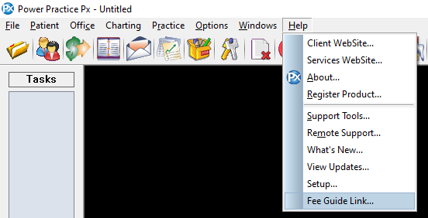

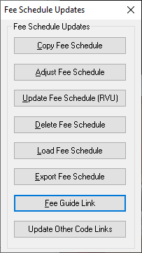
**If you are on an older version and do not have the Fee Guide Link option
From the top menu bar, select the Practice > Maintenance Manager menu option.
- Select the Utilities tab and then select Fee Schedule Updates icon.
- Select Fee Guide Link button.

Highlight the 2026-AR.upd fee guide for the Alberta Regular Fee Guide or the 2026-AB.upd for the Alberta Blue Cross Fee Guide and click the OK button.

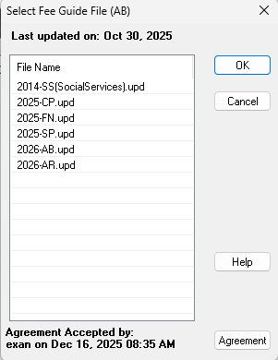

Under the column labeled To Sch: type in the letters AR beside the corresponding AR in the Load Sch: column, then select the OK button.
If loading the Alberta Blue Cross type in AB beside the corresponding AB in the Load Sch:
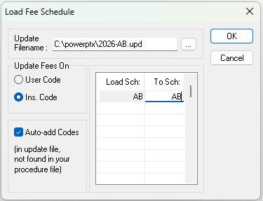
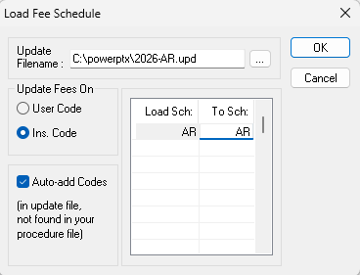

(4.8 clients) If a pop-up message appears asking Do you wish to back up the “R” Schedule? select the Yes button. Otherwise move onto the next steps.

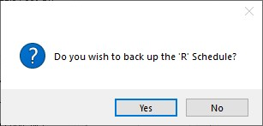

Select the OK button.

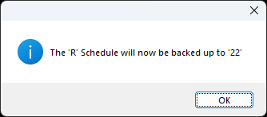

Select the No button (unless you wish to check the new fees)

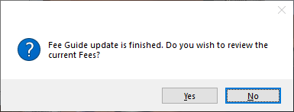


The Fee Guide has now been updated.

Please remember that updating to the current fee schedule does not update existing Planned or Proposed fees to the current fee guide. Detailed instructions for this are available at https://powerpractice.ca/feeguide/

